Pricing­

Summary

1. Choose a pruduct 2

2. Aggregate Demand Curve 2

3. Horizion 4

4. Application of algorithm 5

I. A/B testing 5

II. UCB1 5

III. Thompson Sampling 5

IV. UCB1 and Thompson Sampling comparison 5

5. Context identification 5

I. UCB1 5

II. Thompson Sampling 5

6. References 5

# Choose a pruduct

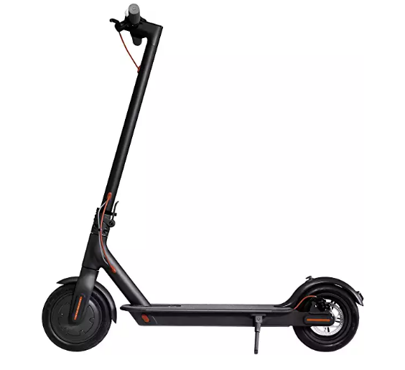After a brief consulting we decided to analyse the price and demand curve of a new technological product.

Our choice fell upon an electric scooter; although already present on the market for some years, the development of more reliable and cheaper batteries has brought on the market last year redesigned products more accessible to the customers.

The price of this item varies from 325€ to 425€ and we chose to analyse this range with five distinct segments.

We assume that a new tech product will have a higher price when launched on the market and then it will be subject to a smooth change during the analysed period.

We also assume the presence of seasonal abrupt changes due to festivities, sales, and/or environmental factors which usually affect this kind of consumer product.

# Aggregate Demand Curve

We decide to divide the customers in 3 different classes of users: *Worker*, *Student*, *Retired*. They split the market according to different percentages, the class composed by workers takes the 75%, students are the 20% and retired people occupy the 5% of the market. In the graph below are shown the disaggregate demand curves based on conversion rates for each price:

The conversion rates of each class are the average of the values estimated for every phase. In particular we assume that we have 4 different phases reflecting the seasons of a year: *Spring*, *Summer*, *Autumn* and *Winter*.

Spring and Summer share the same demand curve. The values are above the average, that’s because we can imagine that in such seasons people are more attracted to our product.

During Autumn phase, at the end of the summer and with the cold weather, people is not so tempted to buy an electric scooter, so the demand curve is below the average demand.

In the Winter phase, the values are a bit below the average for the same reasons of the autumn, but the decreasing is not so accentuated because people thinks forward to the summer and our good can attract people as a Christmas present.

In the following graph are shown the distributions of the different phases:

The average of the demand of the 4 seasons give us the average demand curve:

# Horizion

Based on the price analysed on various online marketplaces such as Amazon and CamelCamelCamel, we decide to set a temporal horizon of one full year for our experiments.

This period of time is divided into 365 individual days, drawing 1000 samples every day.

According to the above-mentioned price research, we chose a set of 5 possible prices, ranging from 325€ to 425€ with 25€ steps.

# Application of algorithm

## A/B testing

For the testing part we implemented an AB/n testing algorithm and we obtained the following plots:

## UCB1

We applied the UCB1 algorithm with the following probabilities:

## Thompson Sampling

After, we applied the Thompson Sampling algorithm

## UCB1 and Thompson Sampling comparison

Finally, we plotted both the algorithms on the same data to highlight the difference between them.

# Context identification

## UCB1

## Thompson Sampling

# References

Some e-commerce links to electric kick scooters:

<https://www.amazon.it/Moma-Bikes-PA0500W2-Monopattino-Antiforatura/dp/B07GDVHNVT/>

<https://www.amazon.it/Ninebot-Segway-Monopattino-elettrico-Taglia/dp/B075XKJM2T/>

<https://www.amazon.it/Xiaomi-Mi-Nero-Unisex/dp/B077QHRLPB/>

<https://www.amazon.it/i-Bike-Monopattino-Elettrico-Pieghevole-autonomia/dp/B07NP2S6P9/>

**METTERE QUI LINK A PRODOTTI AMAZON E EVENTUALI ALTRI SITI CHE ABBIAMO USATO COME REFERENZA**